**NETFLIX Case Study**

**This case study is to analyze the Movies and TV shows on Netflix.**

**Insights from the data analysis and the recommendations could help Netflix in deciding which type of shows/movies to release on the OTT platform and how they can grow the business in different countries**

**Data Exploration and Insight:**

Basic Summary of Data:

**Total Content on Netflix: 8807**(Movies + TV Shows)

Available Columns: 12

**Missing Data:**

director 29.908028 %

cast 9.367549 %

country 9.435676 %

# In the analysis above, missing values were replaced with the "Unknown" category

The number of Unique Values per Columns:

show_id 8807

type 2

title 8807

director 4529

cast 7693

country 749

date_added 1767

release_year 74

rating 17

duration 220

listed_in 514

description 8775

**Type of Content on Netflix:**

Movie 72.202722 %

TV Show 27.797278 %

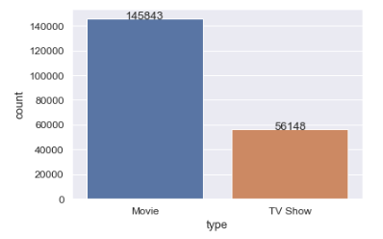

**Rating of Content on Netflix:**

TV-MA 36.581585

TV-14 21.756205

R 12.806799

PG-13 8.045601

TV-PG 7.391890

PG 5.407480

TV-Y7 3.121967

TV-Y 1.815039

TV-G 1.376260

NR 0.779006

G 0.757711

NC-17 0.073790

TV-Y7-FV 0.042590

UR 0.042590

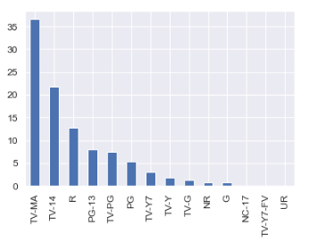

# **Observation number 01:** TV-MA and TV-14 cover more the 50% of the content rating

### Number of Contents present in data as per Age group:

### 

# **Observation number 02:** Content for Adults and Teen cover more the **50%** of the Netflix movie and Tv show base. Therefore, we can say that Adults and teens consume more Netflix content in comparison to other age groups. *Around* ***23%*** *of the content is for kids and older kids.*

**# Content added per year:**

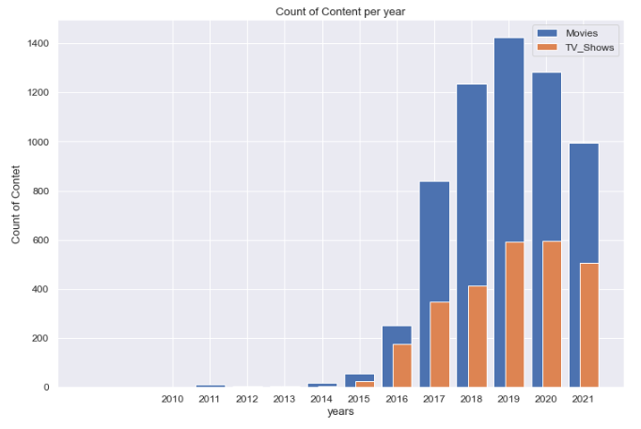

# **Observation number 03:** If we look at the data for the last 10 years in the above plot, we can see clearly that till 2019 there was an increase in the number of contents added per year, and from 2019 to 2020 although there was a dip in movies addon, the TV shows addition remained the same. In the year 2020, we can see a huge dip in both types of content and we can assume that the main reason would have been COVID-19

### # Best director, according to the number of movies

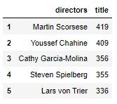

# **Observation number 04:** The best director is Martin Scorsese with 419 titles

### # Best Actor, according to the number of movies

### 

# **Observation number 05:** The best actor is Liam Neeson with 161 titles

### # Number of Content per country:

### 

### # Country wise Movies and Tv shows content per year:

### 

# **Observation number 06:** Japan, South Korea, Taiwan, Cambodia, and Singapore: has more tv show content compared to movies. India and USA have more content Movies compared to TV shows, and for the rest of the countries, it is equally distributed.

**Number of Content per Genre:**

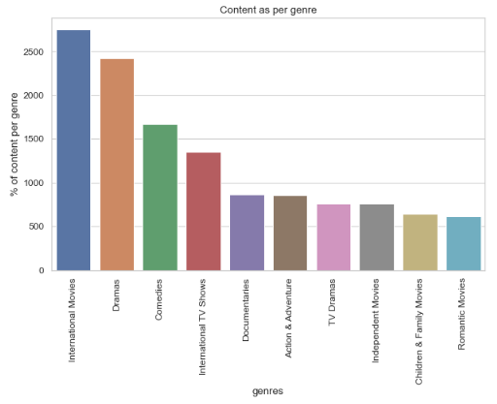

Top 10 Genres Globally watched on Netflix: (65% of the total content is from the below category of genres)

International Movies 14.242095 %

Dramas 12.560161 %

Comedies 8.663251 %

International TV Shows 6.991668 %

Documentaries 4.497231 %

Action & Adventure 4.445479 %

TV Dramas 3.948662 %

Independent Movies 3.912436 %

Children & Family Movies 3.317290 %

Romantic Movies 3.187911 %

# **Observation number 07:**  Globally “International Movies” and “Dramas” are the most popular.

**Actors who have worked internationally:**

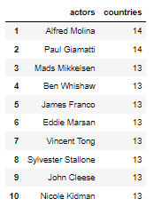

# **Observation number 08:**  Top 10 actors in this list have worked in or have their content watched in more the 12 countries.

**Directors who have worked internationally:**

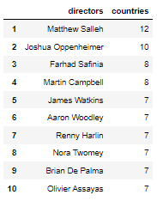

# **Observation number 09:**  Top 10 directors in this list have worked in or have their content watched in more the 6 countries.

### Top 20 Versatile Actors

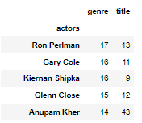

### Top 20 versatile Directors

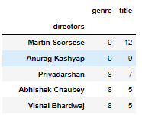

### Movie duration density and graph

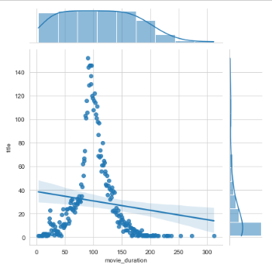

# **Observation number 10:**  the majority of the Movie content is around 75 to 125 min long.

**Content release trend:**

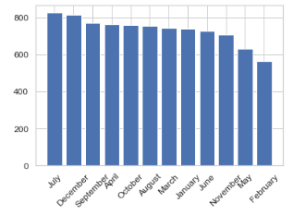 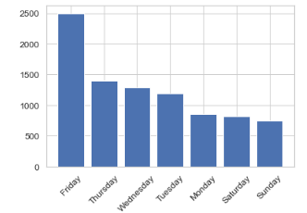

# **Observation number 11:** Most content is released on Friday and in July, December, and September.

Observations:

# **Observation number 01:** TV-MA and TV-14 cover more the 50% of the content rating

# **Observation number 02:** Content for Adults and Teen cover more the **50%** of the Netflix movie and Tv show base. Therefore, we can say that Adults and teens consume more Netflix content in comparison to other age groups. *Around* ***23%*** *of the content is for kids and older kids*

# **Observation number 03:** If we look at the data for the last 10 years in the above plot, we can see clearly that till 2019 there was an increase in the number of contents added per year, and from 2019 to 2020 although there was a dip in movies addon, the TV shows addition remained the same. In the year 2020, we can see a huge dip in both types of content and we can assume that the main reason would have been COVID-19

# **Observation number 04:** The best director is Martin Scorsese with 419 titles

# **Observation number 05:** The best actor is Liam Neeson with 161 titles

# **Observation number 06:** Japan, South Korea, Taiwan, Cambodia, and Singapore: has more tv show content compared to movies. India and USA have more content Movies compared to TV shows, and for the rest of the countries, it is equally distributed.

# **Observation number 07:**  Globally “International Movies” and “Dramas” are the most popular. # **Observation number 08:**  Top 10 actors in this list have worked in or have their content watched in more the 12 countries.

# **Observation number 09:**  Top 10 directors in this list have worked in or have their content watched in more the 6 countries.

# **Observation number 10:**  the majority of the Movie content is around 75 to 125 min long

# **Observation number 11:** Most content is released on Friday and in July, December, and September.

# **Observation number 12:** The shortest movie is “Silent” 3 min long

# **Observation number 13:** Longest movie is “Black Mirror: Bandersnatch” 312 min long.

**Recommendations*:***

1. From observations 1 and 2 we can say that Netflix showed add more content for Adults and Teens, as from last year’s releases we can assume that more than 50% of the content was targeted to Adult and Teen audiences.
2. Netflix should try to add more content of the actors and directors from the top actors and directors list given above, for example, best actor Liam Neeson and best director Martin Scorsese, and their content are for sure going to attract consumers.
3. As Japan, South Korea, Taiwan, Cambodia, and Singapore: has more tv show content compared to movies, Netflix should try to add more TV shows within their native language and actors and directors
4. India and USA have more content Movies compared to TV shows Netflix should try to add more Movies within their native language and actors and directors
5. Although there are movies from 3 min to 312 mins long, Netflix should try to add movies with a length between 75 to 125 mins, as this is the most popular length for movies.
6. Best day to add new content is on Friday, and the best choice of the month is July, December, and September.
7. Netflix should add content with versatile actors, that is a sure way to attract consumers. A list of some popular versatile actors that Netflix can consider is:

|  |  |  |
| --- | --- | --- |
| **Ron Perlman** | 17 | 13 |
| **Gary Cole** | 16 | 11 |
| **Kiernan Shipka** | 16 | 9 |
| **Glenn Close** | 15 | 12 |
| **Anupam Kher** | 14 | 43 |
| **Samuel L. Jackson** | 14 | 24 |
| **Rajesh Sharma** | 14 | 18 |
| **Antonio Banderas** | 14 | 15 |
| **Ben Kingsley** | 14 | 15 |
| **Keith David** | 14 | 15 |
| **Guy Pearce** | 14 | 14 |
| **Jim Broadbent** | 14 | 13 |
| **John Leguizamo** | 14 | 12 |
| **Carla Gugino** | 14 | 11 |
| **Jay Baruchel** | 14 | 11 |
| **Keegan-Michael Key** | 14 | 11 |

1. Netflix should add content with versatile directors, that is a sure way to attract consumers. A list of some popular versatile directors that Netflix can consider is:

|  |  |  |
| --- | --- | --- |
| **Martin Scorsese** | 9 | 12 |
| **Anurag Kashyap** | 9 | 9 |
| **Priyadarshan** | 8 | 7 |
| **Abhishek Chaubey** | 8 | 5 |
| **Vishal Bhardwaj** | 8 | 5 |
| **Vikramaditya Motwane** | 8 | 4 |
| **Ifa Isfansyah** | 8 | 3 |
| **David Dhawan** | 7 | 9 |
| **Clint Eastwood** | 7 | 7 |
| **Ron Howard** | 7 | 7 |
| **Brad Anderson** | 7 | 4 |
| **Jeremy Saulnier** | 7 | 4 |
| **BB Sasore** | 7 | 3 |
| **Guillermo del Toro** | 7 | 3 |
| **Jalil Lespert** | 7 | 3 |

1. It would be an appropriate decision if we add content based on past data as per best actors and directors, or produce more movies specifically for Netflix
2. Countries with a high population like Russia, China, Germany, South Korea, Mexico, Singapore, and Poland, are not in the top countries that consume Netflix content, so Netflix should try to attract those customers, by adding content with those countries’ actors and directors